WADF105 Practical Laboratory Report
TCP/IP, Ethernet, ARP and Wireshark Analysis (Lab 02)
Item | Details
Student Name | Maryjudith Chidinma Ogunaka
Registration Number | C11/26/FCDF/17151
Programme | ICDFA Fellowship in Cybersecurity and Digital Forensics (Cohort 11)
Course | WADF105 Network Security Fundamentals
Laboratory | Lab 02: TCP/IP, Ethernet, ARP and Wireshark Analysis
Platform | Oracle VM VirtualBox
Date | 06 October 2026

1. Aim
The aim of this laboratory was to capture and analyse network traffic generated within the ICDFA virtual laboratory using Wireshark, and to understand how devices communicate across a TCP/IP network. The exercise covered Ethernet and IPv4 addressing, ARP, ICMP, DNS and TCP, and ended with saving the capture as evidence.

2. Objectives
- Examine Ethernet frame communication.
- Investigate ARP requests and replies.
- Analyse the relationship between IPv4 and MAC addresses.
- Capture and analyse ICMP traffic.
- Observe DNS name resolution traffic.
- Analyse TCP connection traffic and the three-way handshake.
- Save the capture in PCAPNG format as evidence.
- Develop packet analysis and troubleshooting skills using Wireshark.

3. Lab Environment

3.1 Virtual machines
The laboratory used the virtual machines built in Lab 01, hosted on Oracle VM VirtualBox.
VirtualBox name | Role | Operating system
ICDFA-NSLAB | Ubuntu Client (Wireshark capture point) | Ubuntu Linux
ICDFA-NSLAB-Firewall | OPNsense Firewall | OPNsense 26.7 (amd64)
ICDFA-NSLAB-DMZ | Ubuntu DMZ Server | Ubuntu Linux
ICDFA-NSLAB-VRouter | Ubuntu VRouter | Ubuntu 24.04 LTS

3.2 Addressing used in this lab
Device | Interface | Address
Ubuntu Client | enp0s3 | 192.168.1.127/24
Ubuntu Client | Default gateway | 192.168.1.1
OPNsense Firewall | LAN (em1) | 192.168.1.1/24
OPNsense Firewall | WAN (em0) | 10.0.2.15/24 (DHCP)
The addressing in this lab (192.168.1.0/24 on the LAN, WAN address by DHCP) differs from the Lab 01 addressing.

3.3 Tools and commands
Tool or command | Purpose
ip -4 -br address | Show the IPv4 address of each interface
ip -br link | Show link-layer (MAC) information
ip route | Show the routing table and default gateway
ip neigh show | Show the ARP (neighbour) table
groups | Check group membership for Wireshark permissions
wireshark --version | head -n 1 | Confirm Wireshark is installed
ping, getent hosts, curl -I | Generate ICMP, DNS and TCP traffic
Wireshark 4.2 | Capture and analyse the traffic

4. Procedure and Evidence

4.1 Baseline verification
Before capturing traffic, the firewall interfaces and the client network settings were verified. The commands in section 3.3 were run on the Ubuntu Client.
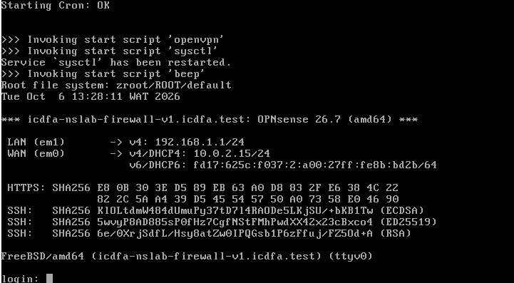
Figure 1: OPNsense firewall console showing the interface addresses.
Observation: The firewall LAN interface (em1) is 192.168.1.1/24 and the WAN interface (em0) received 10.0.2.15/24 by DHCP.
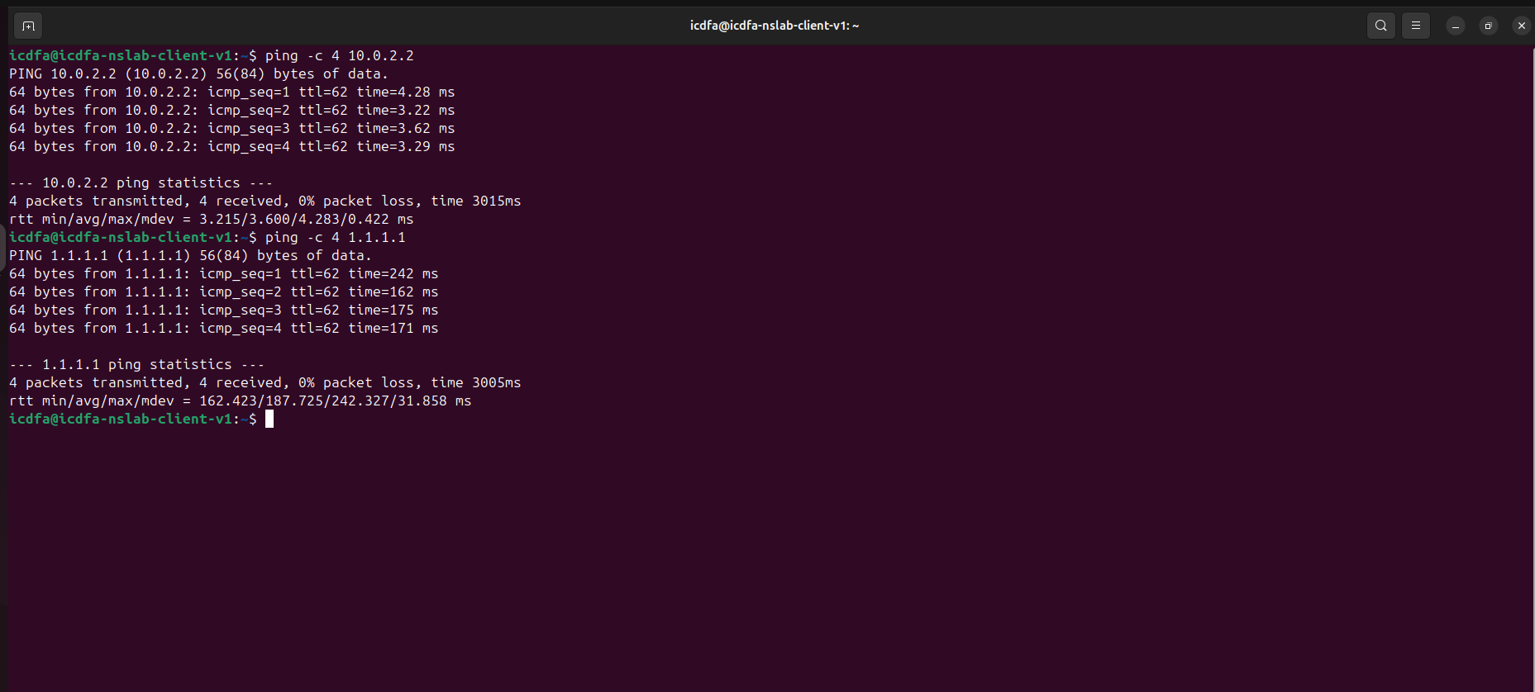
Figure 2: Ubuntu Client: ping -c 4 10.0.2.2 and ping -c 4 1.1.1.1.
Observation: Both tests returned 4 of 4 replies with 0% packet loss. The average round-trip time was about 3.6 ms for 10.0.2.2 and about 187.7 ms for 1.1.1.1.
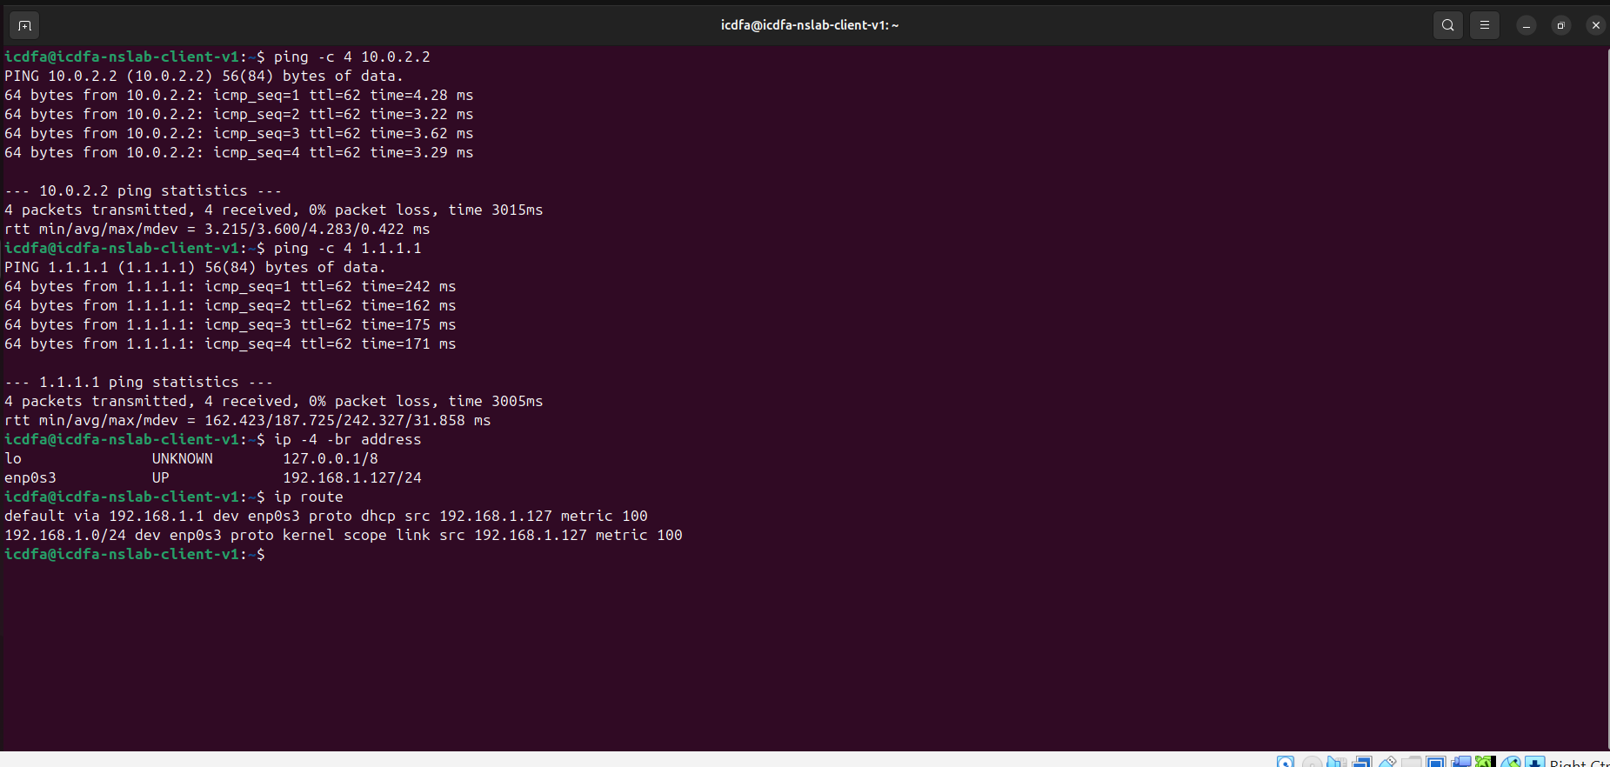
Figure 3: Ubuntu Client: ip -4 -br address and ip route.
Observation: The client holds 192.168.1.127/24 on interface enp0s3. The default route is via 192.168.1.1 (the firewall LAN address), and 192.168.1.0/24 is directly connected.

4.2 ARP analysis
ARP traffic was generated by communicating with the default gateway. In Wireshark, the display filter arp was applied to isolate the ARP packets.
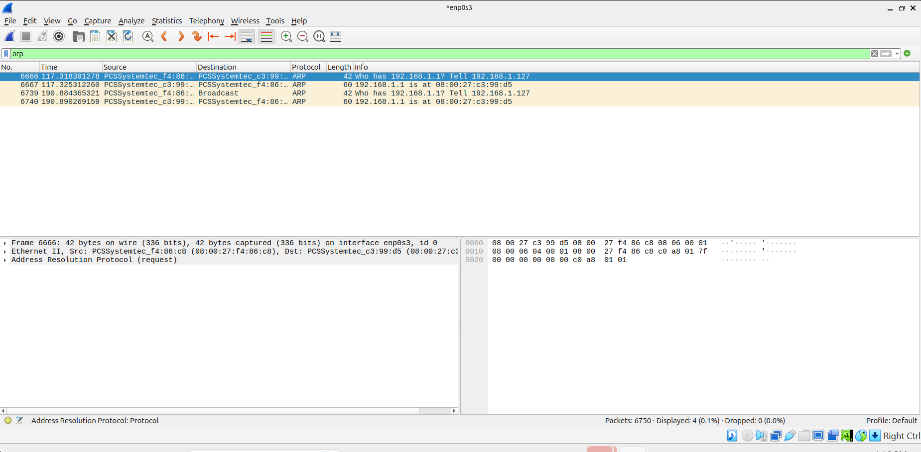
Figure 4: Wireshark with the display filter arp.
Observation: 4 of 6750 packets were displayed. The client sent the request "Who has 192.168.1.1? Tell 192.168.1.127", and the firewall answered "192.168.1.1 is at 08:00:27:c3:99:d5". This is how the client learned the MAC address of its gateway.

4.3 ICMP analysis
ICMP traffic was generated with the ping command, and the display filter icmp was applied.
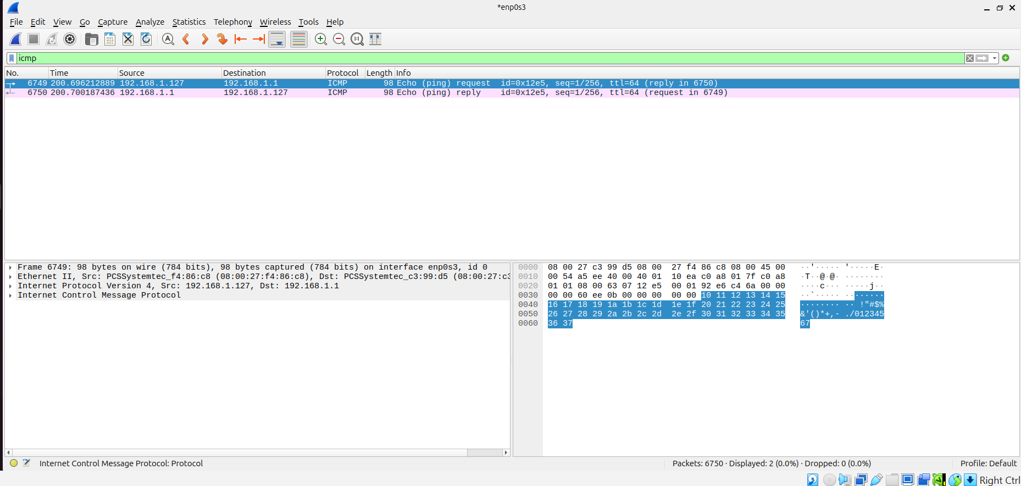
Figure 5: Wireshark with the display filter icmp.
Observation: An Echo Request and an Echo Reply were captured between 192.168.1.127 and 192.168.1.1, with TTL 64 on the request. Wireshark links each request to its reply by the identifier and sequence number.

4.4 DNS analysis
DNS traffic was generated with the command getent hosts google.com.
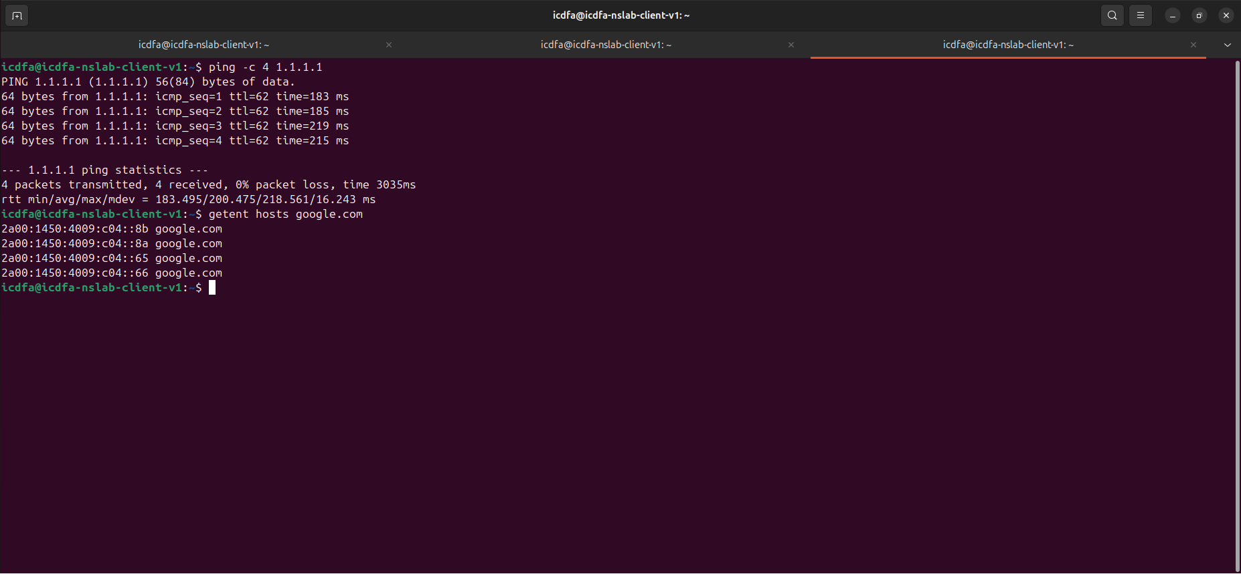
Figure 6: Ubuntu Client: ping -c 4 1.1.1.1 and getent hosts google.com.
Observation: The domain name google.com resolved to IPv6 addresses (2a00:1450:4009:c04::8b, ::8a, ::65 and ::66), so name resolution was working.
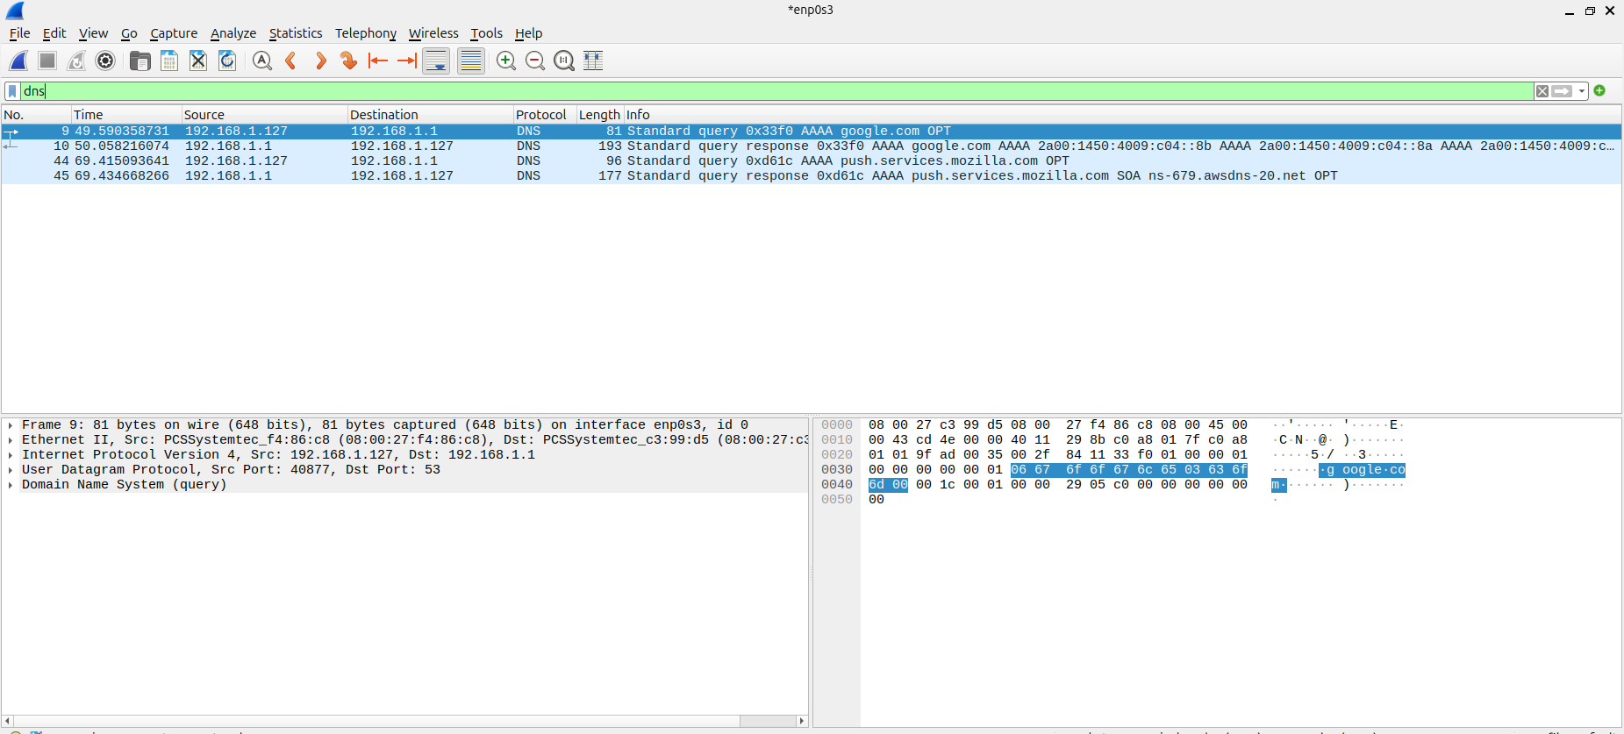
Figure 7: Wireshark with the display filter dns.
Observation: The client (192.168.1.127) sent a DNS query for google.com to the firewall (192.168.1.1) over UDP port 53, and the firewall returned a standard query response. The capture also shows queries for push.services.mozilla.com, which came from background browser activity.

4.5 TCP analysis
Web traffic was generated with the command curl -I https://google.com.
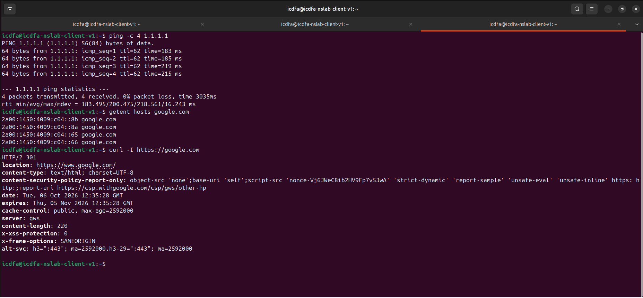
Figure 8: Ubuntu Client: curl -I https://google.com.
Observation: The server replied with HTTP/2 301 and a location header pointing to https://www.google.com/. This confirms the client could open an encrypted web connection.
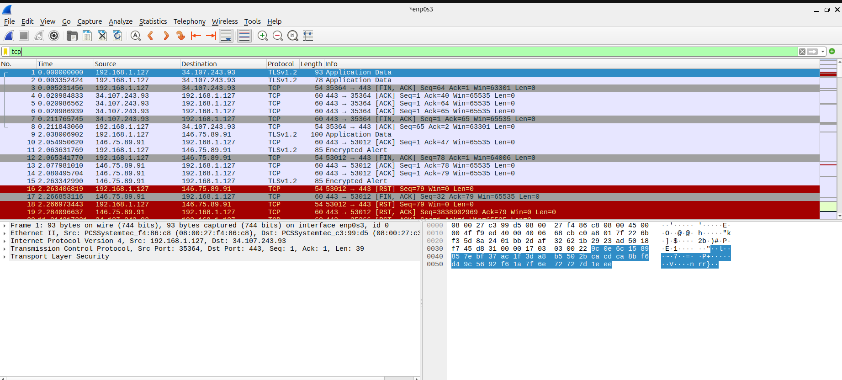
Figure 9: Wireshark with the display filter tcp.
Observation: The capture shows TCP connections from 192.168.1.127 to remote servers on port 443, with TLS application data, FIN/ACK packets for closing connections, and RST packets (shown in red).
A TCP connection starts with a three-way handshake:
- The client sends a SYN packet.
- The server replies with a SYN-ACK packet.
- The client sends an ACK packet, and the connection is established.

4.6 Packet capture evidence
The capture was saved in PCAPNG format using File > Save As in Wireshark.
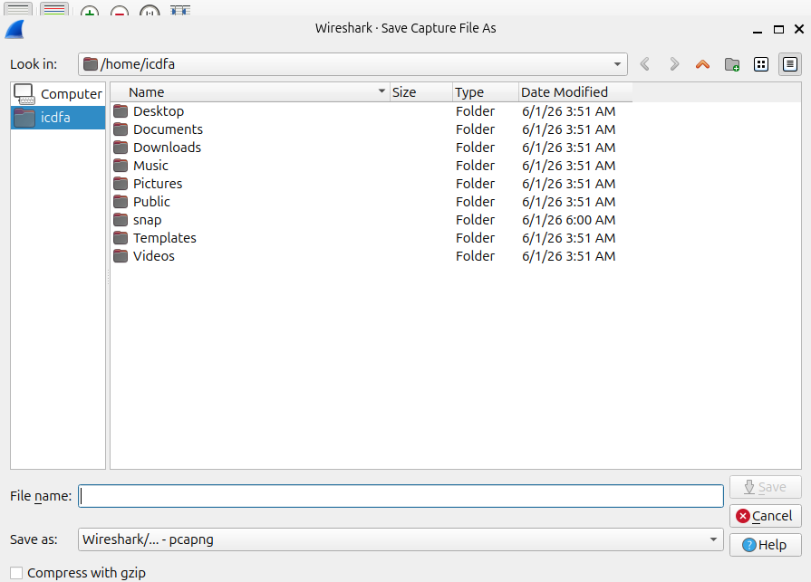
Figure 10: Wireshark Save Capture File As window, with the file type set to pcapng.
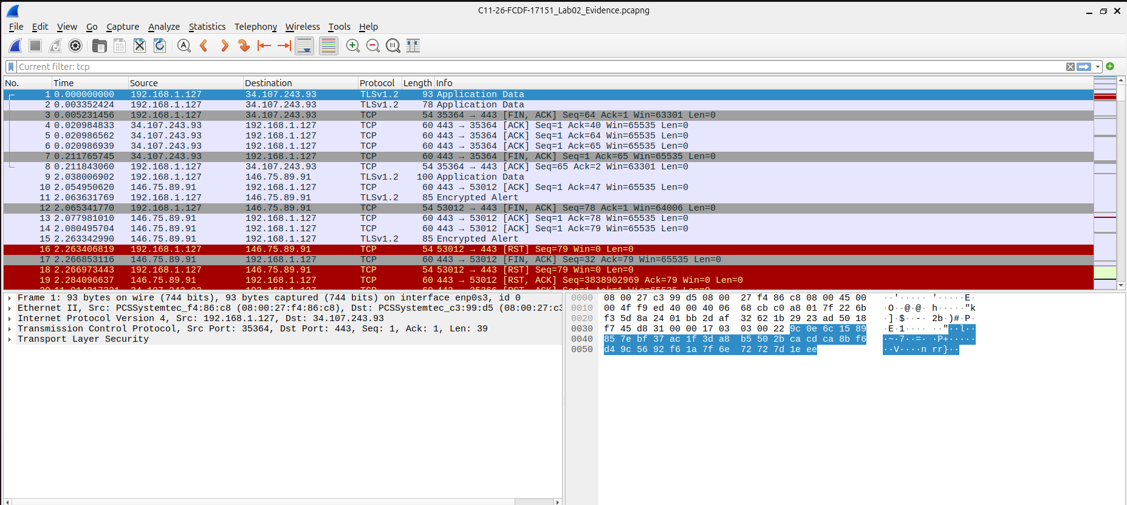
Figure 11: Wireshark showing the saved capture file in the title bar.
Observation: The capture was saved as C11-26-FCDF-17151_Lab02_Evidence.pcapng. It contains ARP, ICMP, DNS and TCP traffic.

5. Protocol Explanation
- ARP request: it is sent as a broadcast (destination MAC FF:FF:FF:FF:FF:FF) because the sender knows the IP address but not the MAC address of the device it wants to reach.
- ARP reply: it is sent directly (unicast) back to the requester, because the replying device learned the requester's MAC address from the request.
- MAC and IP addresses: Ethernet uses MAC addresses to deliver frames on the local network, while IPv4 uses IP addresses for end-to-end communication, so the two addresses differ.
- Evidence from the firewall: the ARP reply "192.168.1.1 is at 08:00:27:c3:99:d5" shows the OPNsense firewall supplied its own MAC address.
- Capture filter and display filter: a capture filter limits which packets are stored while capturing, while a display filter only changes which of the stored packets are shown.

6. Troubleshooting and Notes
- The capture contained 6750 packets, so display filters (arp, icmp, dns and tcp) were used to isolate each protocol.
- The DNS filter also showed background queries (push.services.mozilla.com) that were not part of the test.
- Connections in the TCP capture were closed with FIN/ACK and RST packets, which Wireshark highlights in red.
- If TCP communication fails, the layers to check are the physical layer (cabling and interface status), the data link layer (MAC addressing and ARP), the network layer (IPv4 addressing, routing and gateway) and the transport layer (TCP ports and the handshake).

7. Results Summary
Test | Result
IPv4 address, default gateway and route verification | PASS
ARP request and reply captured | PASS
ICMP echo request and reply captured | PASS
DNS query and response captured | PASS
TCP traffic to port 443 captured (HTTPS) | PASS
Capture saved as PCAPNG | PASS

8. Conclusion
The objectives of the laboratory were achieved. Network traffic was generated, captured and analysed in Wireshark, and ARP, ICMP, DNS and TCP communication were all observed. ARP resolved the gateway IP address to a MAC address, ICMP confirmed reachability, DNS translated a domain name into IP addresses, and TCP carried the encrypted web traffic. The capture was saved as a PCAPNG file for evidence and future analysis.

